

1 Year – 1 SEM

2023-2024

Pearson HND in Computing (Level 4)

Najwa Mohammed Islam

Dr. Mahmoud Alkhouli

Unit 3: Professional Practice

Table of Contents

• **Introduction** 4

**Introduction of Effective Communication:-** 5

**What is communication?** 5

**Types of Communication:** 5

**• Verbal Communication** 6

**• Non - Verbal Communication** 8

**Navigating the Spectrum** 11

**The Versatility of Communication Styles** 12

**Understanding Interpersonal Skills** 13

**Ensuring Smooth Collaboration** 15

**The Holistic Approach to Interpersonal Skills** 16

**Two Days Training Schedule** 19

**The two days training event is scheduled in Gantt chat which is represented in the given diagram:-** 21

**First day of training** 23

**Second Day of Training** 24

**Navigating Efficiency through Effective Time Management** 25

**Understanding SMART Goals** 26

**Problem-Solving Techniques in Event Design and Delivery** 28

**Critical Thinking: The Backbone of Problem-Solving** 31

Table 1. Evidence of Problem Solved 34

**DMAIC – The Six Sigma’s Problem-Solving Method:** 35

**Root Cause Analysis:** 36

**Kipling Method: The 5W1H Approach** 38

**Trial-and-Error Method: Discovering Optimal Solutions** 39

**Pareto Principle: The 80/20 Rule** 39

**Report on Group Formatting and Team Dynamics** 41

**Team Dynamics:** 43

**Importance of Team Dynamics:** 44

**Team Collaboration in the 2-Day Event** 45

**Beyond Productivity:** 47

**Benefits of CPD:** 52

**Tailoring CPD Programs:** 53

**The Importance of CPD:** 53

**How CPD Helps:** 54

**Measuring the Effectiveness of CPD:** 54

**Introduction to Personal Development Plan (PDP):** 56

**Key Components and Purpose of PDPs:** 56

**PDPs in Professional and Educational Contexts:** 57

Table 2. Evidence of CPD 60

**Introduction to Motivation Theory:** 61

**Implications of Motivation Theories in the Workplace:** 65

**Conclusion:** 65

References 66

* **Introduction**

I work as an intern at Cognizant Pvt Ltd in Dubai, which is a software company. My primary responsibility is to assist the Training and Development Manager in preparing and implementing a professional development event for the target audience. This professional development event will span over two days and will be held in our company hall designated for workshops and training courses. This event will include a range of activities, including workshops, training sessions and team building exercises. To facilitate the finalization of event plans, there is a need to compile a comprehensive schedule detailing the types of activities that will be offered, so I have been given the responsibility of designing and delivering a workshop focusing on the complexities of the dynamics of effective teamwork. To successfully accomplish the above tasks I must use a variety of skills. This includes proficiency in effective communication, strong interpersonal skills, and efficient time management.

Team building activities are a common way to build camaraderie between workers and to develop personal relationships between team members. Though they aren’t always loved by all, team building activities do benefit employees and organizations as whole. So finding and organizing activities your team members will actually enjoy is an important step in cultivating and fostering a thriving company culture.

A team-building event can form the foundation of improved morale among colleagues. Management can identify leadership strengths among employees. Co-workers will learn the value of co-operation. They are also able to display abilities outside of work skills.

4

**Introduction of Effective Communication:-**

Effective communication is an essential factor for building a work team capable of collective work, as good communication reduces the occurrence of any friction or misunderstanding in the workplace, and this results in the presence of cohesive work teams capable of taking responsibility for the work and adept at solving problems that may stand in their way and moving forward. Moving forward towards achieving the organization's goals.

Effective communication involves a variety of skills, including nonverbal communication, active listening, emotional awareness, and the ability to manage stress. Communication can be achieved through spoken language, as well as through facial expressions, gestures, movements, postures, and touch.[1]

**What is communication?**

Humans do not just utilize one way of communicating. They adopt various methods through which communication occurs. Communication is a process that involves sending and receiving messages through the verbal and non-verbal methods and it is a two-way means of communicating information in the form of thoughts, opinions, and ideas between two or more individuals with the purpose of building an understanding.[1]

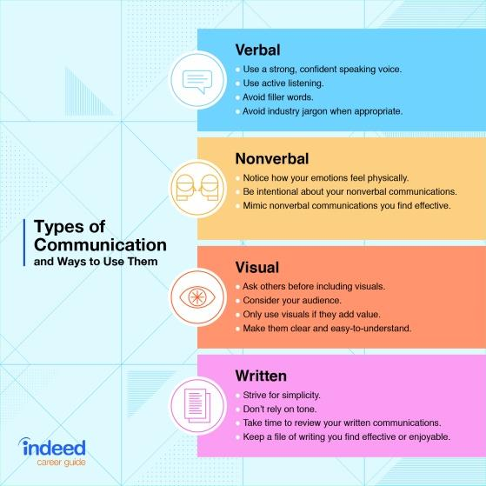**Types of Communication:**

The four types of communication are verbal, non-verbal, visual and written communication. No matter how we communicate, start by thinking about what the reader/listener should think, feel and do once they've heard or read our message.

There are several different ways we share information with one another. For example, you might use verbal communication when sharing a presentation with a group. You might use written communication when applying for a job or sending an email. Here’s a more in-depth look at the four main categories of communication:[2]

Fig.1. Types of Communication

5

**• Verbal Communication**

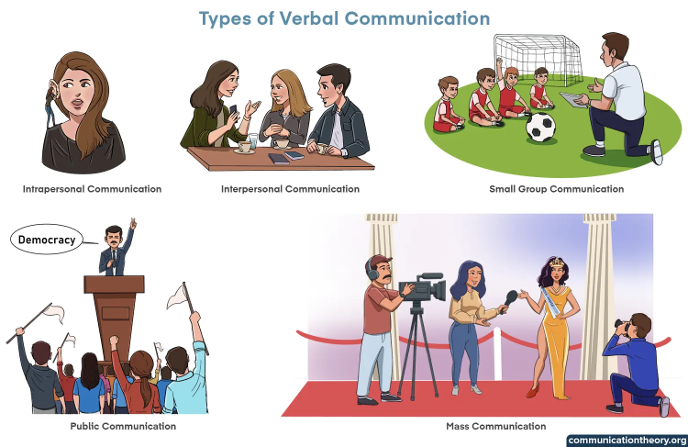Verbal communication can also be called as Oral communication. It is a type of communication where we use spoken and written words to convey our message and information to the other person. In other words, when we use our words to express ourselves, our feelings, and our thoughts, we are communicating verbally. The method of verbal communication can also be classified into different types and they are:[2]

* Intrapersonal communication
* Interpersonal communication
* Small group communication
* Public communication
* Mass communication

Fig.2. Types of Verbal Communication

**Intrapersonal communication**

It is a person’s communication with himself by relying on his mind after interacting with the outside world, through several methods, including talking, imagining, or visualizing. Self-communication takes several forms, represented by talking to oneself out loud, writing, or thinking.

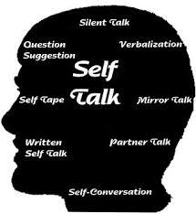**For example**, Emily always has the habit of discussing with herself before taking any important decisions. She feels that talking to herself helps her tackle any confusion efficiently.[2]

Fig.3. Intrapersonal Communication

6

**Interpersonal communication**

This type of communication is also called “Dyadic communication” and it takes place between two or more individuals. This method involves various aspects of

communication such as listening, speaking and responding through words and various acknowledging non-lexical fillers such as “uh-huh”, “hmm” and some head and hand gestures etc.[3]

Fig.4. Interpersonal Communication

**Small group communication**

This is a type of interaction that takes place in a small group between three or more people. Among the characteristics of communication in a small group, there are important characteristics of communication in small groups, the most important of which is achieving joint tasks and finding solutions through the exchange of information and opinions. One of the advantages of groups is to encourage members to overcome problems. Some examples of small group communication are board meetings, team discussions etc. All the members of the group unanimously discuss and conclude.[3]

Fig.5. Small group Communication

**Public communication**

In this communication, one speaker conveys information to a large group of people. This takes place in a setting where a large group of people assemble to receive the information from the speaker. Some examples of this type of communication involve election campaigns, public speeches etc. where information is passed on from one common source to hundreds of individuals.[3]

Fig.6. Public Communication

7

**Mass communication**

It is “the process by which a person, group of people, or large organization creates and conveys a message using some type of media to a broad, unknown, heterogeneous group of audiences.” Mass communication is regularly associated with media influence or media effects, and media studies. Mass communication is a branch of the social sciences that falls under the larger umbrella of communication or communication studies.[3]

Fig.7. Mass Communication

**• Non - Verbal Communication**

**Unlocking the Power of Non-Verbal Communication: A Brief Guide**

Communication is a rich tapestry woven not only with words but also with the silent language of non-verbal cues. These unspoken signals, ranging from facial expressions to body language, play a pivotal role in our daily interactions, often conveying more than words alone can express.[2]

**Understanding Non-Verbal Communication**

Non-verbal communication involves the transmission of messages without the use of words. It encompasses various elements, including facial expressions, gestures, posture, eye contact, and even silence. To truly master communication, it's essential to recognize and interpret these subtle cues.[2]

8

**The Impact of Body Language**

Gestures and body movements are universal forms of expression that transcend language barriers. A simple nod can convey agreement, while crossed arms may signal defensiveness. Being aware of your own body language and attuned to others' can significantly enhance interpersonal communication.[2]

**The Eyes Have It: Eye Contact as a Powerful Tool**

Eye contact is a fundamental aspect of non-verbal communication. It signifies confidence, attentiveness, and sincerity. Maintaining appropriate eye contact establishes a connection and ensures that your message is received with clarity and trust.[2]

**Reading Faces: Facial Expressions Speak Louder Than Words**

Our faces are a canvas of emotions, revealing joy, surprise, anger, or sadness. Understanding facial expressions enables us to gauge others' feelings accurately, fostering empathy and strengthening the emotional resonance of our interactions.[2]

**The Silent Power of Posture**

Posture is a silent communicator of confidence, authority, or openness. Standing tall and maintaining good posture not only positively influences how others perceive us but also boosts our own self-confidence in communication.[2]

**Proxemics: Navigating Personal Space**

The concept of personal space varies across cultures, influencing the comfort levels of individuals during interactions. Being mindful of proxemics, or the distance maintained between people, ensures respectful and effective communication in diverse settings. [2]

9

**Silence: A Potent Communicative Tool**

Silence is a powerful element of non-verbal communication. Pauses can add emphasis, allow for reflection, or convey a range of emotions. Knowing when to embrace silence is as important as choosing the right words.[2]

**Cultural Considerations in Non-Verbal Communication**

It's crucial to recognize that non-verbal cues may vary across cultures. What is considered acceptable eye contact or appropriate gestures in one culture may differ in another. Cultural sensitivity enhances effective communication in diverse environments.[2]

**Incorporating Non-Verbal Skills in Professional Settings**

Non-verbal communication plays a pivotal role in the professional realm. Job interviews, presentations, and workplace interactions are enriched when individuals are adept at utilizing non-verbal cues to convey professionalism, confidence, and engagement.[2]

**Mastering the Art of Non-Verbal Communication**

Understanding and harnessing the power of non-verbal communication is a skill that transcends spoken words. By paying attention to body language, gestures, and facial expressions, individuals can foster deeper connections, avoid misunderstandings, and convey messages with precision. Remember, communication is not just about what you say but how you say it.

Whether in personal relationships, professional settings, or cross-cultural interactions, the ability to interpret and employ non-verbal cues is a valuable asset. So, let your body speak, your eyes connect, and your posture resonate, for in the silent language of non-verbal communication, true understanding flourishes.[2]

10

There are some communication skills which I am going to use in my 2 days of event.

Styles of Communication skills:

• Passive Communication

• Assertive Communication

• Aggressive Communication

• Proficiency in effective communication

• Strong interpersonal skills

• Efficient time management

**Navigating the Spectrum**

Communication is a dynamic process, and the nuances of formal and informal dialogue add layers of complexity to our interactions. These two distinct styles of communication play pivotal roles in shaping the tone, language, and structure of conversations. A closer look at formal and informal dialogue unveils their unique characteristics and the significance they hold in various social and professional settings.[4]

**Formal Dialogue**

Formal dialogue is the language of professionalism, tailored for structured environments and official interactions. This style adheres to established norms, often characterized by a carefully chosen vocabulary, adherence to grammatical rules, and a tone that reflects respect and formality. Commonly found in business meetings, academic presentations, or official correspondences, formal dialogue aims for clarity and precision.[4]

11

In a professional context, mastering formal communication is crucial for establishing credibility and conveying authority. It sets the stage for respectful exchanges, fosters a sense of professionalism, and ensures that information is conveyed with the requisite gravity. Whether in the corporate world, academia, or government, understanding and employing formal dialogue is a key competency.[4]

**Informal Dialogue**

Contrastingly, informal dialogue thrives in casual, social settings where a relaxed rapport is encouraged. This style of communication is characterized by a more spontaneous and easy-going tone, often incorporating colloquial language, humor, and a familiarity between participants. Informal dialogue is the language of friendships, family gatherings, and social outings.[4]

In social interactions, mastering informal communication is equally vital. It facilitates a sense of camaraderie, nurtures personal connections, and promotes a comfortable atmosphere. Informal dialogue allows individuals to express themselves more freely, fostering a genuine exchange of ideas and emotions. Whether at a social event, among friends, or in personal correspondence, understanding and adapting to informal dialogue enriches relationships and builds connections.[4]

**The Versatility of Communication Styles**

The key to effective communication lies in recognizing the appropriate context for each style. Formal and informal dialogue is not mutually exclusive; rather, they represent points on a spectrum. A skilled communicator seamlessly transitions between these styles based on the demands of the situation. Flexibility in communication style ensures adaptability in diverse environments.[5]

12

**Balancing Act: Mastering Both Styles**

In summary, formal and informal dialogue serve different purposes and are adapted to specific social and professional contexts. Mastering both styles of communication is essential for effective interpersonal relationships and navigating diverse social environments. The ability to discern when to employ a formal tone for professional engagements and when to embrace informality for social connections is a valuable skill.[5]

Communication, in its varied forms, is the cornerstone of successful interactions. Whether engaged in a boardroom discussion or sharing a laugh with friends, understanding the nuances of formal and informal dialogue enables individuals to navigate the intricacies of social dynamics. Embracing the versatility of communication styles ensures that each interaction is not just a conversation but a tailored exchange that resonates with the context and enhances the quality of relationships.

**Understanding Interpersonal Skills**

Interpersonal skills are the set of behaviors and strategies individuals employ to engage effectively with others. These skills are omnipresent, influencing interactions in the workplace, social situations, and within family dynamics. In professional contexts, interpersonal skills specifically pertain to an employee's ability to collaborate harmoniously with colleagues, clients, and superiors.[5]

**Defining Soft Skills**

Soft skills encompass a broad array of capacities crucial for individuals to excel and progress in their respective professions. Examples of these skills include:[6]

13

1. **Personal Effectiveness:**
   * Utilizing all personal resources—talents, abilities, energy, and time—to achieve life and work goals.
   * Enhancing personal performance through self-awareness, maximizing talents, acquiring new abilities, and fostering behavioral flexibility.
2. **Working with Others:**
   * Recognizing the importance of teamwork in various aspects of life.
   * Contributing effectively to a team, fostering trust, open communication, and conflict resolution.
3. **Use of Initiative:**
   * Demonstrating the ability to think and act independently, taking proactive steps without explicit instructions.
4. **Negotiating Skills:**
   * Professionally engaging in discussions and reaching decisions collaboratively.
   * Recognizing the role of initiative in problem-solving and decision-making.
5. **Assertiveness Skills:**
   * Being confident and maintaining a positive outlook on oneself and others.
   * Fostering self-assurance, focus, loyalty, self-worth, and respect for oneself and others.

14

1. **Social Skills:**
   * Engaging and communicating effectively with others through body language, gestures, and appearance.
   * Harnessing strong social skills for building connections, improving communication, enhancing efficiency, and expanding employment opportunities.

**Ensuring Smooth Collaboration**

The ultimate aim of developing interpersonal skills is to facilitate cooperation with minimal conflict in the workplace. Here's a closer look at key soft skills:

**1. Personal Effectiveness:**

* Leveraging personal resources for goal attainment.
* Emphasizing self-awareness, talent maximization, skill acquisition, and behavioral adaptability.

**2. Working with Others:**

* Embracing teamwork as an integral part of personal and professional life.
* Cultivating an environment of trust, open communication, and effective conflict resolution within teams.

**3. Use of Initiative:**

* Encouraging independent thinking and proactive task completion.
* Highlighting the importance of taking initiative in professional settings.

15

**4. Negotiating Skills:**

* Recognizing negotiation as a vital component of successful corporate communication.
* Understanding that initiative is the driving force behind inventive solutions.

**5. Assertiveness Skills:**

* Cultivating confidence, self-assuredness, focus, and loyalty.
* Upholding self-worth and respecting the rights of one self and others.

**6. Social Skills:**

* Mastering the ability to engage and communicate effectively.
* Enjoying the benefits of improved connections, communication, efficiency, and enhanced career prospects.

**The Holistic Approach to Interpersonal Skills**

Mastering interpersonal skills is essential for thriving in diverse personal and professional environments. These skills, categorized as soft skills, encompass a spectrum of capabilities that enhance collaboration, communication, and overall effectiveness. Whether navigating teamwork, exercising initiative, negotiating professionally, asserting oneself confidently, or showcasing social prowess, a holistic approach to interpersonal skills is key to success in today's interconnected world.[5]

Effective communication is the cornerstone of success in various facets of life. While words play a significant role, the manner in which we convey messages extends beyond mere verbal expression. Let's dive into distinct formats of communication skills, recognizing that true mastery involves more than just the spoken word.

16

**1. Workshops**

Workshops serve as dynamic platforms for interactive learning and skill development. Unlike traditional lectures, workshops engage participants actively, encouraging hands-on experiences and collaborative problem-solving. These sessions, often led by experts in the field, foster an environment where knowledge is not just absorbed but applied, enhancing practical communication skills.[1]

**2. Webinars**

In the digital age, webinars have emerged as powerful tools for disseminating information and fostering communication skills. These online seminars bring together individuals from diverse geographical locations, providing a virtual space for interactive discussions, presentations, and Q&A sessions. Webinars bridge gaps, allowing participants to enhance their communication skills from the comfort of their own spaces.[1]

**3. Role-Playing Exercises**

Communication skills thrive in real-world scenarios, and role-playing exercises provide a simulated environment for practical application. Whether in educational settings or corporate training, role-playing allows participants to step into different roles, enhancing their ability to communicate effectively in a variety of situations. This experiential approach cultivates adaptability and quick thinking in communication.[1]

**4. Networking Events**

Networking events go beyond the exchange of business cards; they are arenas for refining communication skills in a social context. These gatherings facilitate interactions with diverse individuals, necessitating the ability to convey ideas clearly and establish rapport swiftly. Mastering communication in networking events opens doors to professional opportunities and collaborations.

17

**5. Storytelling Workshops**

The art of storytelling is a potent form of communication that transcends facts and figures. Storytelling workshops focus on honing the ability to convey information through compelling narratives. Whether in business presentations or personal anecdotes, storytelling enhances the impact of communication by creating a memorable and relatable experience for the audience.

**6. Team-Building Activities**

As highlighted in the initial example, team-building activities remain integral to developing effective communication within a group. Unity is not just a goal but a prerequisite for success. Activities that promote teamwork necessitate clear communication, emphasizing the importance of expressing ideas, listening actively, and collaborating seamlessly.

**7. Public Speaking Courses**

Public speaking courses provide structured guidance in honing one of the most crucial communication skills—articulation. These courses focus on voice modulation, body language, and the art of engaging an audience. Developing proficiency in public speaking equips individuals to convey messages persuasively in various settings, from boardrooms to public forums.

**8. Cross-Cultural Communication Training**

In an increasingly interconnected world, cross-cultural communication is vital. Training programs addressing this aspect equip individuals with the skills to navigate cultural nuances, fostering effective communication in international settings. Understanding diverse communication styles enhances collaboration and minimizes misunderstandings.

18

Mastering communication skills goes beyond traditional methods. Embracing diverse formats ensures a holistic approach to effective communication. Whether through interactive workshops, virtual webinars, experiential role-playing, or specialized courses, each avenue contributes to enhancing the multifaceted skill of communication. By recognizing the importance of these varied formats, individuals can tailor their approach to communication, adapting to the demands of different contexts and enriching their personal and professional interactions.

**Two Days Training Schedule**

**Day 1**

9:00 AM - 9:30 AM

• Welcome address and introduction to the workshop

• Introducing my team member

9:30 AM - 10:30 AM

• Introduction to Effective Communication

• Types of Communication

10:30 AM - 11:00 AM: Coffee Break

11:00 AM - 12:00 PM

• Introduction to Formal and Informal Dialogue

12:00 PM - 1:00 PM

• Activity to Break the Ice

1:00 PM - 1:30 PM

• Discuss with Trainees

• Summary of the day's session

19

**Day 2**

9:00 AM - 9:30 AM

• Brief overview of the previous day's key points

• Clarifications on any questions or concerns

9:30 AM - 10:30 AM

• Introduction to Interpersonal Skills

• What are Interpersonal Skills?

10:30 AM - 12:00 PM

• Introduction to SOFT SKILL

• Examples of this capacity

12:00 PM - 12:15 PM: Coffee Break

12:15 PM - 1:00 PM

• Activity to Break the Ice

1:00 PM - 2:00 PM: Lunch Break

2:00 PM - 3:00 PM

• Introduction to Time Management

• Time Management Skills

3:00 PM - 3:45 PM

• Activity to Break the Ice

3:45 PM - 4:30 PM

• Discuss with Trainees

• Summary of the day's session

4:30 PM - 5:00 PM

• Closing remarks and gratitude

20

**The two days training event is scheduled in Gantt chat which is represented in the given diagram:-**

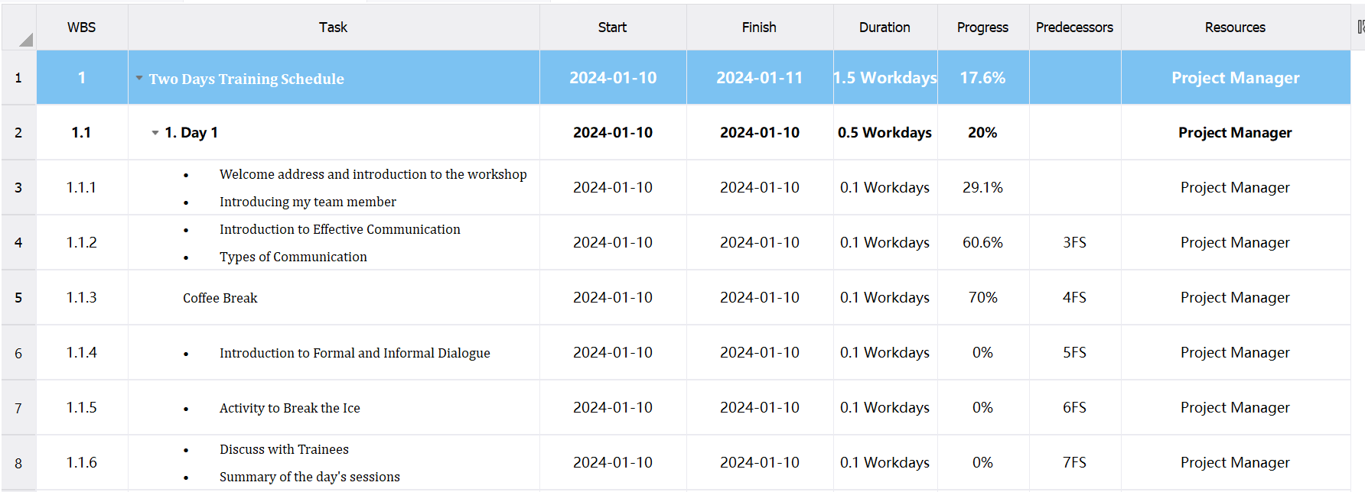

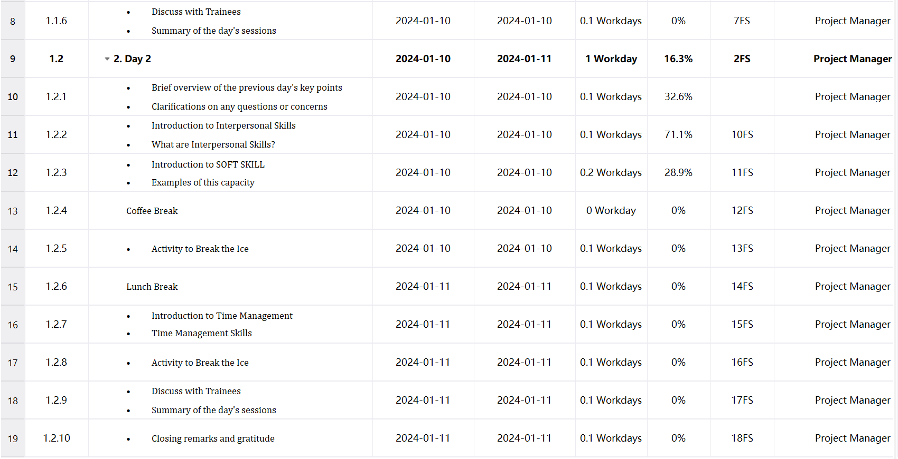

Fig.8. 2 day event schedule

21

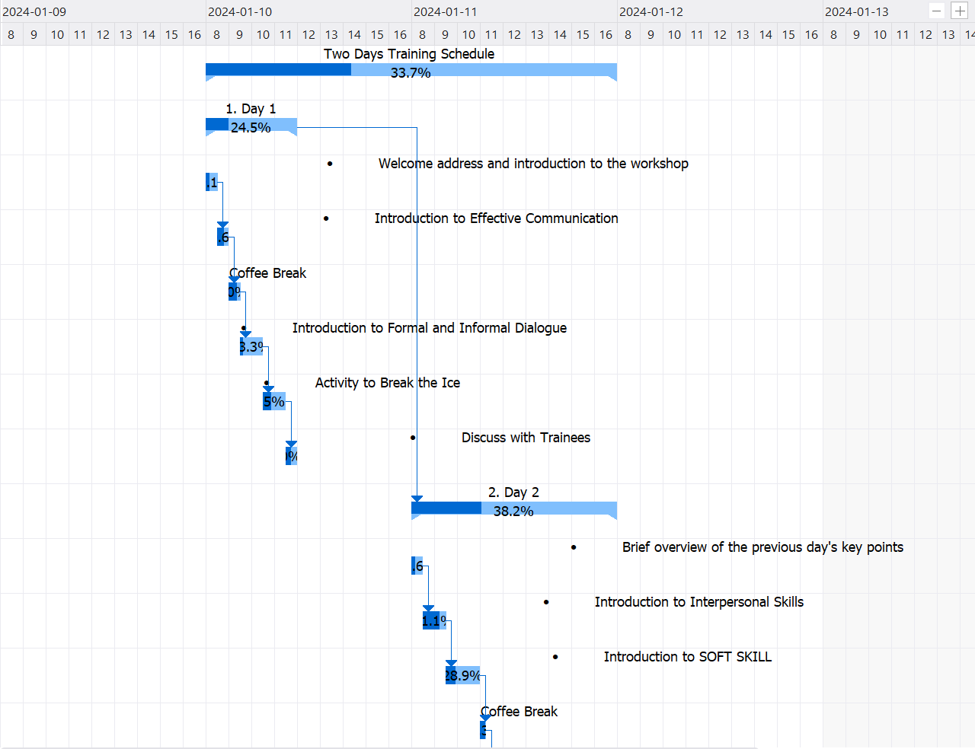

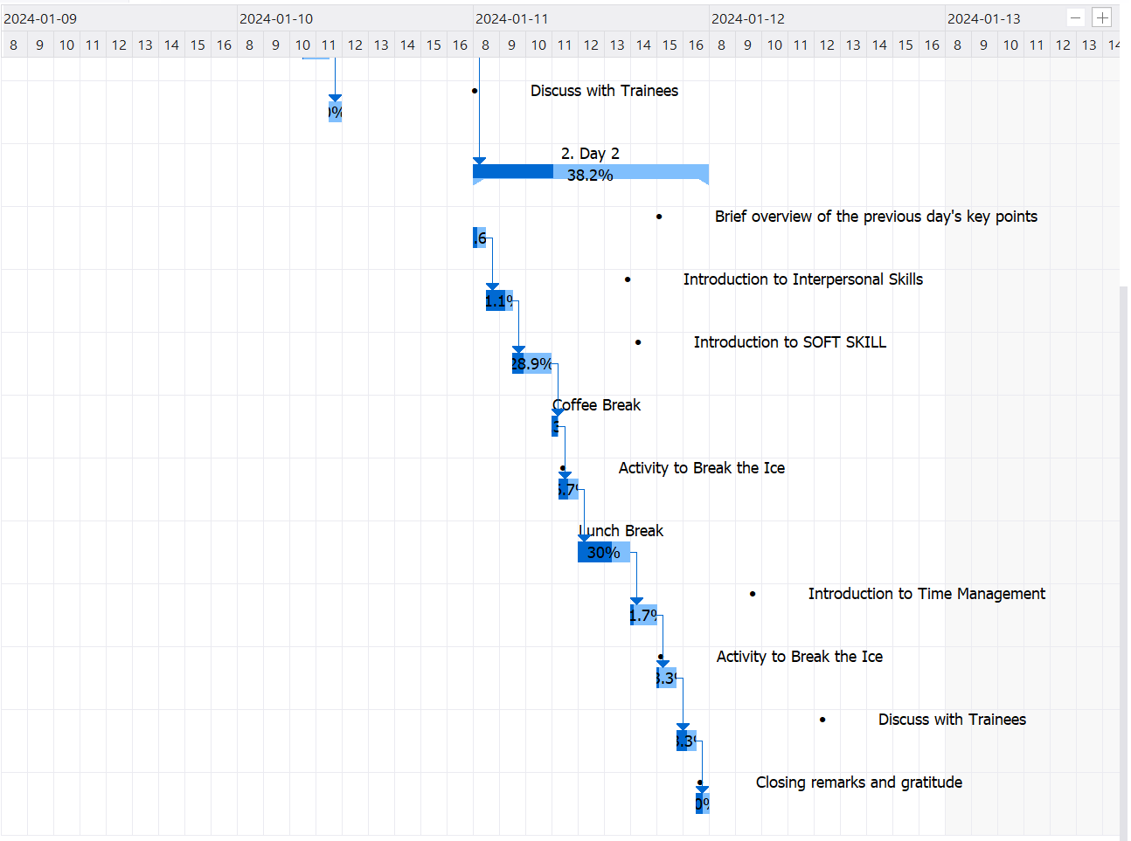

Fig.9. Gantt chart for 2 day event schedule

22

**First day of training**

The two days training program will be conducted on Wednesday and Thursday on 1/10/2024 and 1/11/2024in Cognizant Pvt Ltd, Dubai. The time duration for this session is Four and a half hours, from 9:00AM-1:30PM. In first half hour of first day, there will be a Welcome address and introduction to the workshop and Introducing my team member. After the completion of introduction part, we will begin with an introduction to Effective Communication and Types of Communication till 10:30AM. After that there will be a Coffee break time from 10:30AM 11:00AM. In between the interval of 11:00AM and 12:00PM, there will be introduction to Formal and Informal Dialogue. After the completion of Introduction to Formal and Informal Dialogue, I will do an ice breaker activity and team building exercise, two truths and a lie is an easy game to break the ice between workers and a new colleague. They push colleagues to get personal, forming an easy bond, till 1:00PM. At last, before ending our first day training program there will be Discuss with Trainees and Summary of the day's session for an half hour to explore the knowledge that they gain in a single day and to clear their doubts related to today's topic. In this way the first day will be completed.

23

**Second Day of Training**

The second day will be started in same venue but the duration will be longer. The time duration for this session is eighth hours, from 9:00AM-5:00PM. It will begin with Brief overview of the previous day's key points and Clarifications on any questions or concerns for half hour till 9:30am. Then, a one hour is scheduled for Introduction to Interpersonal Skills and what are Interpersonal Skills? Between the interval of 10:30AM and 12:00PM, there will be Introduction to SOFT SKILL and Examples of this capacity. After that there will be a Coffee break time from 10:30AM 11:00AM. After the completion from Coffee Break, I will do an ice breaker activity and Team-building exercises, the one-word icebreaker game; this game provides an informal avenue to learn employee thoughts on an aspect of work. This could be a new policy, company culture, or even the methods of a supervisor, till 1:00PM. Following that, one hour will be dedicated to Lunch Break 1:00 PM - 2:00 PM. After that there will be an Introduction to Time Management and Time Management Skills 2:00 PM - 3:00 PM. After that there will be an ice breaker activity and Team-building exercises, this activity create a bond between teammates. ​​Colleagues build relationships when they learn personal facts about team members, till 3:45PM. After that there will be a Discuss with Trainees and Summary of the day's sessions 3:45 PM - 4:00 PM. At last, before ending our second day training program there will be Closing remarks and gratitude for an half hour . In this way the first day will be completed.

24

In conclusion, our meticulously planned and well-executed event stands as a testament to the commitment to enhancing professional development. The inclusion of various activities tailored to the specific needs of our audience reflects a strategic approach to skill-building. Each training session, thoughtfully scheduled, ensures optimal time utilization and meaningful engagement.

The success of this two-day training event is attributed to the application of proficient time management skills and effective interpersonal communication. By employing these key competencies, we have created an environment conducive to learning and collaboration, reaching a broad audience with targeted content.

The training programs embedded within this event are not just comprehensive but also tailored to cater specifically to the needs of employee. As we reflect on the success of this endeavor, it is evident that the careful integration of skills, planning, and a keen understanding of our audience has made this event not only effective but also immensely beneficial for the professional growth of participants.

**Navigating Efficiency through Effective Time Management**

In the meticulous planning of our two-day training event, the deployment of effective time management skills played a pivotal role in shaping a well-organized and engaging program. Time management, as the process of efficiently organizing and planning the allocation of time among specific activities, became the linchpin for success. Recognizing the potential stress and diminished effectiveness associated with poor time management, I strategically applied this skill to ensure that our event was not only attractive but also attentive to the needs of our diverse audience. Despite encountering complications that initially seemed challenging within the given six-hour duration, I decided to follow a structured time management procedure.[7]

25

**Prioritizing Workloads**

To organize the event effectively, I employed a series of time management skills. The first step involved prioritizing workloads, emphasizing the most urgent tasks. I meticulously listed all activities, assigning variable time intervals with a particular focus on vital topics, such as Team Building. The first day was dedicated to Essential Communication, Types of Communication, and Formal and Informal Dialogue; each allotted 1 to 1.5 hours. The second day prioritized Interpersonal Skills, Soft Skills, and Time Management, with one hour dedicated to each and 1.5 hours for the latter. This deliberate allocation ensured that critical topics received the attention they deserved, contributing to the overall success of the event.[7]

**Setting Objectives**

Subsequently, I set clear and achievable objectives, aligning with SMART goals—specific, measurable, achievable, relevant, and time-specific. The primary aim was to successfully complete the training event within the stipulated two days, ensuring that each specific activity was carefully defined and time-based. This approach not only facilitated effective time management but also provided a framework for success.[8]

**Understanding SMART Goals**

SMART goals provide a structured and effective framework for setting objectives across various domains. The acronym SMART stands for Specific, Measurable, Achievable, Relevant, and Time-Specific, emphasizing a comprehensive approach to goal-setting that ensures clarity, feasibility, and successful outcomes.[8]

**1. Specific: Precision in Objectives**

The "S" in SMART emphasizes the importance of specificity in goal-setting. Specific goals are well-defined, leaving no room for ambiguity. This precision helps in clearly understanding what needs to be achieved, creating a roadmap for success.[8]

26

**2. Measurable: Quantifying Progress**

Measurable goals allow for tangible tracking of progress. Establishing clear criteria enables individuals to gauge their advancement, providing a quantifiable measure of success. Measurability adds accountability and motivation to the goal-setting process.[8]

**3. Achievable: Realistic and Attainable Objectives**

The "A" underscores the significance of setting goals that are both realistic and attainable. Goals should stretch individuals to grow and achieve, but they must also be grounded in practicality. Achievable goals maintain motivation and instill a sense of accomplishment.[8]

**4. Relevant: Aligning with Purpose and Context**

Relevance ensures that goals align with broader objectives and contribute meaningfully to one's overarching mission. Each goal should have a clear connection to the broader context, ensuring that efforts are directed towards impactful outcomes.[8]

**5. Time-Specific: Setting a Definite Timeframe**

Time-specific goals are characterized by a clearly defined timeframe for completion. This element adds urgency and discipline to the goal-setting process, preventing procrastination and providing a sense of structure to the pursuit of objectives.[8]

27

**Guiding Success with SMART Goals**

SMART goals provide a robust and versatile framework for goal-setting, applicable across personal, professional, and organizational realms. The principles of Specificity, Measurability, Achievability, Relevance, and Time-Specificity collectively contribute to the effectiveness of goal-setting, ensuring clarity, accountability, and successful outcomes. Whether applied individually or within a team setting, embracing the SMART criteria guides individuals and organizations towards a path of strategic and purposeful goal achievement.[8]

**The Impact of Effective Time Management**

The impact of effective time management on our event planning was profound. The strategic application of time management skills ensured a seamless and impactful training program. This approach not only adhered to time constraints but also met the specific needs of our diverse audience. As we reflect on the success of this endeavor, it is evident that the careful integration of time management skills, strategic planning, and a keen understanding of our audience contributed to the effectiveness and overall success of the two-day training event.[8]

**Problem-Solving Techniques in Event Design and Delivery**

**Unveiling the Significance of Problem-Solving**

In this report, the focus is on showcasing the utility of diverse problem-solving techniques in both the design and delivery phases of organizing an event. Individuals often grapple with challenges in personal and practical spheres, necessitating a structured approach to problem-solving. The report delves into the definition of problem-solving, explores its techniques in event design, and highlights problem-solving skills during the delivery of an event.[9]

28

**Problem-Solving Techniques**

Problem-solving abilities encompass the capacity to identify issues, generate and evaluate ideas, and implement optimal solutions. A proficient problem solver is not only a self-starter but also a collaborative team player. They proactively unearth the root of an issue and work collaboratively to assess various alternatives before deciding on the best course of action. Critical thinking and analytical skills are integral to effective problem resolution, making strong problem-solving abilities invaluable in any organizational context.[9]

**Defining the Problem**

The initial stage in resolving an issue is defining the problem itself. A successful problem solver considers diverse perspectives, recognizing that different individuals may have varying notions about the core cause of the problem. In the context of organizing an event, challenges encountered may range from unpredictable weather conditions and electrical issues to insufficient seating arrangements. A comprehensive understanding of the problem lays the foundation for effective problem resolution.[9]

**Exploring Possibilities**

After defining the problem, the next step involves brainstorming potential solutions. By generating a multitude of ideas, including insights from data analysis and input from various stakeholders, the goal is to explore all possible options comprehensively. Soliciting feedback from others at this stage is invaluable, as it can introduce alternative solutions that might not have been considered initially. For instance, when faced with challenges such as adverse weather conditions, electrical problems, or a shortage of seating during event planning, brainstorming yielded creative solutions like providing rainproof clothing, bringing a generator and an electrician, and bringing additional plastic chairs.[9]

29

**Decision-Making and Collaboration**

Following the exploration of possible solutions, the focus shifts to selecting the most viable one. Decision-making involves employing problem-solving methods and techniques, often benefitting from collaboration and feedback. Sharing ideas with others and seeking their opinions contribute to a more informed decision-making process. This collaborative approach ensures that the chosen solution aligns with diverse perspectives and insights.[9]

**Implementation Plan**

With the optimal solution selected, the final step is to create an implementation plan. This strategy includes steps for testing, gathering feedback, and making necessary modifications to ensure the chosen solution's feasibility and success. Monitoring compliance and success is integral to the implementation plan, offering a proactive approach to addressing any unforeseen challenges that may arise during the execution of the solution.[9]

The effective deployment of problem-solving techniques is pivotal in navigating the complexities of event design and delivery. From defining problems and brainstorming solutions to making informed decisions and implementing strategic plans, a structured problem-solving approach enhances the efficiency and success of organizing events, ensuring a seamless and rewarding experience for all involved stakeholders.



30

In the culmination of my two-day event, the implementation of diverse problem-solving techniques, as outlined earlier, played a pivotal role in orchestrating a delightful and well-executed occasion. This report will elucidate the specific methods employed and shed light on how they contributed to the seamless organization of the event.

**Critical Thinking: The Backbone of Problem-Solving**

Critical thinking, defined as the capacity to think clearly and rationally, discerning the logical connections between ideas, served as the backbone of problem-solving throughout the event. It requires active engagement with information, urging individuals to question assumptions and explore the deeper reasons behind occurrences. In the context of event management, being an active learner rather than a passive recipient of information proved fundamental to overcoming challenges.[9]

**Application of Critical Reasoning: Addressing Key Challenges**

In this segment of the assignment, the focus is on demonstrating the application of critical reasoning to specific scenarios encountered during the event. Several challenges were navigated with a critical thinking approach, ensuring a comprehensive evaluation of each issue:[9]

1. **Load Shedding:**
   * Critical thinking involved a thorough analysis of the power supply situation.
   * Contingency plans were devised, including the use of generators and alternative power sources.

31

1. **Electric Device Failures:**
   * A critical examination of the event's electrical setup.
   * Immediate troubleshooting and collaboration with on-site technicians to address device failures promptly.
2. **Not Enough Seats:**
   * A critical evaluation of the seating arrangement and attendee count.
   * Quick adjustments, including the addition of extra seats and reorganizing the seating plan to accommodate the audience.
3. **Medical Emergency:**
   * Critical decision-making in response to a medical emergency.
   * Coordination with medical personnel, timely assistance, and an immediate review of event safety protocols.

**A Successful Event through Critical Problem-Solving**

The event's success can be attributed to the application of critical thinking and problem-solving techniques. The ability to question assumptions, analyze situations, and implement informed decisions ensured that challenges were not just addressed but transformed into opportunities for improvement. Each problem encountered was met with a thoughtful and rational approach, demonstrating the effectiveness of critical reasoning in navigating the complexities of event management. As we reflect on the event's positive outcomes, it is evident that the integration of critical thinking skills played a crucial role in delivering a memorable and seamlessly organized occasion.[9]

32

|  |  |  |  |  |
| --- | --- | --- | --- | --- |
| **Problem**  **Identify** | **Problem** **Analyze** | **Possible**  **solutions** | **implementation plan** | **Evaluation** |
| Load Shedding | The issue of load shedding poses a significant challenge to the smooth execution of the event. Load shedding can disrupt the power supply and impact various aspects of the event, from lighting to audio-visual equipment. | Deploying generators to ensure an uninterrupted power supply during load shedding. Conducting a thorough assessment of power requirements to determine the appropriate generator capacity. | Identify reliable generator providers and establish a contract for their services.  Conduct a simulation to test the effectiveness of the generator backup.  Ensure the availability of an on-site technician for immediate troubleshooting. | Periodically review the effectiveness of the generator backup system through simulated load shedding scenarios. |
| Electric Device Failures | Electric device failures can hamper the flow and effectiveness of the event. Technical malfunctions in devices such as microphones, projectors, or sound systems may result in interruptions and compromise the overall experience. | Having a dedicated technical support team on standby to address and resolve any device failures promptly.  Regularly testing and maintaining all electronic devices before the event to minimize the risk of failures. | Collaborate with experienced technical support teams and include them in event planning.  Create a pre-event checklist for device testing and maintenance.  Establish a dedicated communication channel for reporting and addressing technical issues. | Monitor the frequency and nature of electric device failures during pre-event testing and the actual event. |
| Medical Emergency | A medical emergency demands immediate attention and efficient handling to ensure the well-being of the affected individual. Failure to respond promptly can lead to serious consequences. | Developing and communicating a comprehensive emergency response plan.  Ensuring the availability of trained medical personnel and first aid kits at strategic locations throughout the event venue. | Develop and disseminate an emergency response plan to all event staff.  Coordinate with local medical services to ensure timely response to emergencies.  Conduct emergency drills to familiarize event staff with the protocol. | Analyze the response time and effectiveness of the emergency response plan through periodic drills and real-time scenarios. |
| Not Enough Seats | Insufficient seating arrangements can lead to discomfort for attendees and affect the overall ambiance of the event. This problem requires a swift resolution to ensure a positive experience for all participants. | Maintaining a contingency supply of additional chairs to swiftly address any shortage.  Regularly monitoring attendee registrations to adjust seat arrangements accordingly. | Source additional chairs and have them readily available for quick deployment.  Regularly update the seating plan based on attendee registrations.  Train event staff on efficient and discreet seat adjustments to minimize disruptions. | Collect feedback from attendees regarding seating comfort and overall event experience. |

Table 1. Evidence of Problem Solved

34

**Problem-Solving Techniques for Website Research**

In this task, the focus was on researching websites and applying a mix of problem-solving techniques to address various scenarios. The selected problem-solving methodologies included DMAIC, the Six Sigma's Problem-Solving Method, and Root Cause Analysis. These techniques provide structured approaches to define measure, analyze, improve, and control processes, ensuring systematic and effective problem resolution.[9]

**DMAIC – The Six Sigma’s Problem-Solving Method:**

**Define:** The initial step in DMAIC involves precisely defining the problem or project goals. For website research, this could mean outlining specific objectives, target metrics, and the scope of the research. A well-defined problem sets the foundation for accurate measurements and successful project completion.[10]

**Measure:** Following the definition, the Measure phase requires judgments on additional measures needed to quantify the problem. In the context of website research, this could involve assessing the current performance of the website, gathering data on user interactions, and establishing a baseline for comparison.[10]

**Analyze:** Once measurements are in place, the Analyze phase focuses on gathering and analyzing data to identify the root cause of the problem. This phase helps determine if the issues are genuine or random occurrences. Data collected serves as a baseline for evaluating the success of the project after implementation.[10]

**Improve:** The Improve phase follows data analysis, where potential solutions are generated and tested. For website research, this could involve optimizing user interfaces, enhancing navigation, or improving content structure. Pilot studies help assess the effectiveness of solutions before full-scale implementation.[10]

**Control:** After implementation, the Control phase establishes measures to validate the ongoing success of the solution and prevent recurrences. This could include regular monitoring, data collection, and documentation updates to ensure sustained improvement.[10]

35

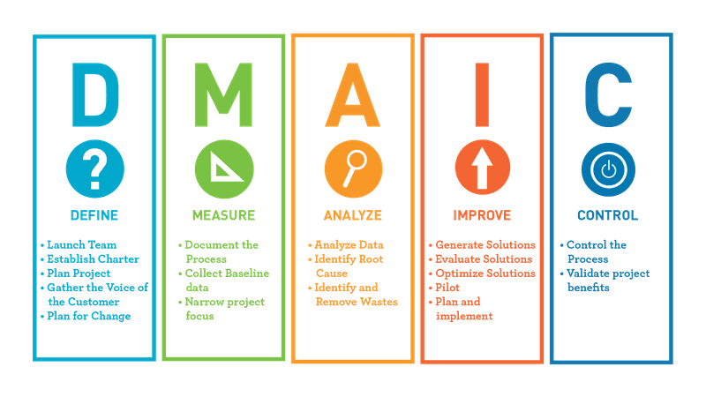

When applied to website research, DMAIC offers a systematic roadmap, aligning with Six Sigma principles, and can lead to significant improvements in website performance and user experience.

**Root Cause Analysis:**

Root Cause Analysis, attributed to Saki chi Toyoda, involves probing the underlying causes of an issue by repeatedly asking "Why." The approach is particularly effective for addressing pre-existing problems and is structured into six major phases[10].

1. **Define the Problem:**
   * Clearly articulate the problem statement related to the website, such as user engagement issues or performance bottlenecks.
2. **Data Collection:**
   * Gather relevant data, considering user feedback, analytics, and performance metrics.

36

1. **Identify Likely Reasons:**
   * Develop a list of potential reasons for the identified problem based on collected data.
2. **In-Depth Examination:**
   * Use techniques like the 5 Whys or Fishbone diagram to delve deeper into the root cause.
3. **Propose Solutions:**
   * Once the root cause is identified, propose effective solutions to address the underlying issues.
4. **Execution:**
   * Implement the chosen solutions and monitor their impact on resolving the identified problem.

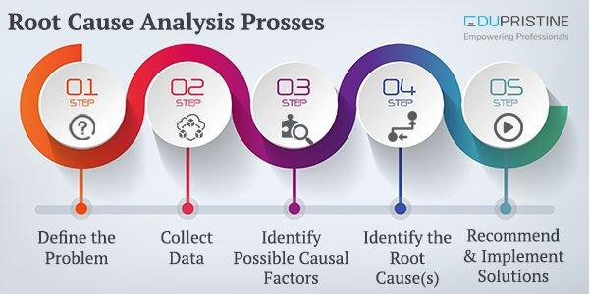

Combining DMAIC and Root Cause Analysis provides a robust problem-solving framework for website research, offering a strategic and thorough approach to address challenges and enhance overall website performance.

37

**Problem-Solving Methods in Event Organization**

In this discussion, various problem-solving methods are explored, each serving a unique purpose in tackling challenges. The Kipling method, trial-and-error method, and Pareto principle are discussed as valuable tools for comprehensively addressing issues. Furthermore, a justification is provided, showcasing the application of these methods in the organization of an event.[9]

**Kipling Method: The 5W1H Approach**

The Kipling method, also known as 5W1H, is a powerful questioning and problem-solving strategy. By answering the essential parts of an issue – what, who, where, when, why, and how – a comprehensive understanding is gained. In the context of event organization, questions like where the event will take place, what will be presented, when the lectures will occur, and how tasks will be distributed among teams are vital. Answering these questions strategically helps identify potential solutions and sets the groundwork for successful event planning.[11]

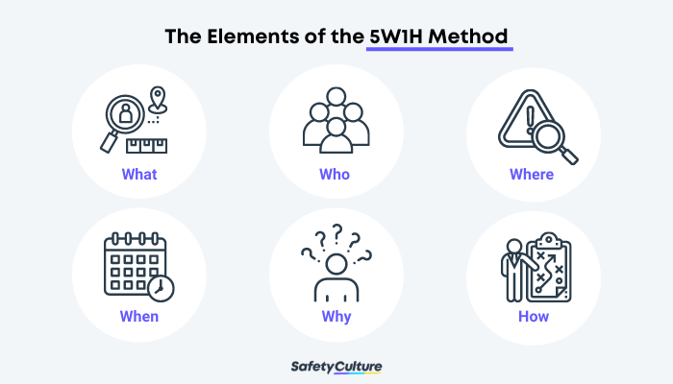

38

**Trial-and-Error Method: Discovering Optimal Solutions**

The trial-and-error method involves attempting various methods or techniques to identify the most effective way to achieve a desired outcome. It is characterized by learning from errors and refining approaches based on experience. This method is valuable in event planning, allowing organizers to experiment with different strategies and refine the event's structure, logistics, and content based on observed successes and failures.[12]

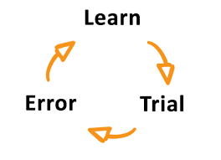

**Pareto Principle: The 80/20 Rule**

The Pareto principle, often known as the 80/20 rule, is employed to identify significant factors contributing to a problem. Although not a strict mathematical law, it suggests that approximately 80% of outcomes result from 20% of inputs. In event organization, this principle can help identify critical aspects influencing success. For instance, recognizing that 20% of event elements may contribute to 80% of attendee satisfaction allows organizers to focus efforts on optimizing those crucial aspects.[13]

39

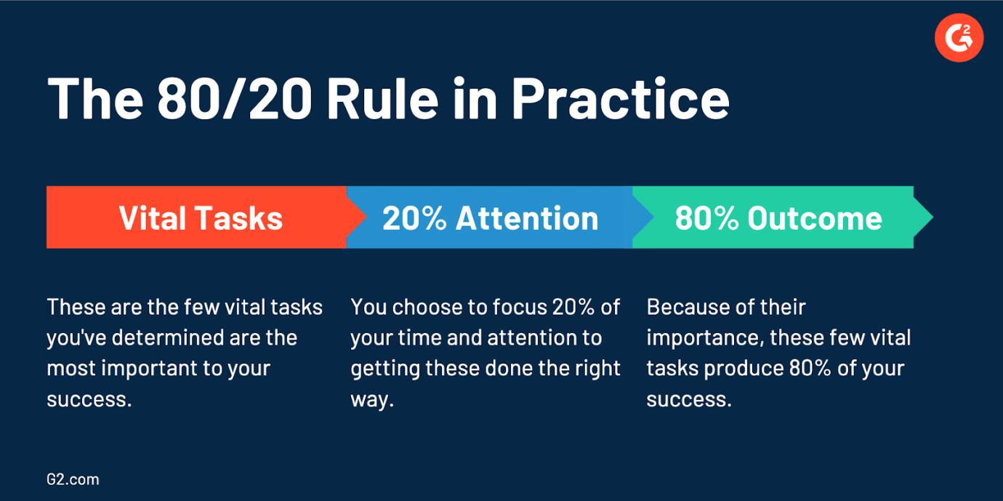

**Justification**

In the organization of an event, a combination of problem-solving methods was employed to address diverse challenges. The Kipling method played a role in establishing the foundational aspects of the event – determining the where, what, when, why, and how. To solve more complex issues within the team, the DMAIC approach from Six Sigma was utilized. This involved defining the problem, measuring team members' qualifications, analyzing results, proposing solutions, and deciding on the best approach. By incorporating various skills and methods, a holistic problem-solving approach was employed to ensure the successful organization of the event.

The integration of the Kipling method, trial-and-error approach, and Pareto principle, along with the structured DMAIC method, showcases a comprehensive problem-solving strategy. The success of event organization is attributed to the thoughtful application of these methods, demonstrating adaptability and efficiency in overcoming challenges.

40

**Report on Group Formatting and Team Dynamics**

**Introduction:** This report aims to explore the formatting of groups, emphasizing Tuckman's model to understand the stages of group development. Additionally, the concept of team dynamics will be discussed, highlighting its significance in determining the success of a group.

**Formatting of Groups: Tuckman's Model**

*Tuckman's Stages:* The process of group development, as outlined by Tuckman, consists of five stages: Forming, Storming, Norming, Performing, and Adjourning. These stages provide a framework to comprehend the evolution of groups over time.[14]

1. **Forming:**
   * In the Forming stage, the team's structure is established. Members may feel uncertain and seek acceptance, often looking to a group leader for guidance. Confrontation is avoided, and the emphasis is on forming a cohesive group. [14]
2. **Storming:**
   * During Storming, inherent differences in working methods among team members become apparent. Interpersonal problems surface as tasks and procedures are structured. Questions of leadership, power, and structure dominate this stage, requiring the team to navigate and resolve conflicts. [14]
3. **Norming:**
   * Norming sees the development of new methods of collaboration. Shared leadership emerges as the group builds cohesiveness, shifting away from a single leader. Trust becomes essential for effective shared leadership, fostering a more collaborative and cooperative environment. [14]

41

1. **Performing:**
   * The Performing stage signifies true interdependence within the group. Members adapt to each other's needs, creating a flexible and efficient team. This stage is marked by high productivity and effective collaboration, representing a culmination of the group's growth. [14]

**Advantages and disadvantages of teamwork or formatting group:**

|  |  |
| --- | --- |
| **Advantages** | **disadvantages** |
| Shearing new ideas | Greater chance of conflict between individual learners. |
| Increasing collaboration and clear scope for what to do. | Segregation of individuals can occur. |
| Improve team members’ skills such as communication and time management. | Things can get rowdy and out of hand. |
| Helps in solving complex problems | Reaching agreement can be difficult. |

*Real-world Dynamics:* It's crucial to note that real-world teams frequently shift between these stages, influenced by various factors such as new members joining or changes in project requirements. Tuckman's model offers valuable insights for understanding and managing these transitions.

**Team Dynamics: Importance for Success**

*Definition:* Team dynamics refer to the patterns of interaction and collaboration within a group. Understanding and harnessing positive team dynamics are essential for achieving group goals and ensuring overall success.[15]

*Significance:*

1. **Communication:**
   * Effective team dynamics foster open communication, ensuring that information flows seamlessly among members. Clear communication is vital for avoiding misunderstandings and promoting a shared understanding of goals. [15]

42

1. **Collaboration:**
   * Positive team dynamics encourage collaboration, where members work together harmoniously, leveraging each other's strengths. Collaborative efforts result in enhanced creativity and problem-solving.
2. **Adaptability:**
   * Teams with strong dynamics can adapt to changing circumstances more efficiently. Adaptable teams navigate challenges with resilience, maintaining focus on goals despite external pressures. [15]
3. **Motivation:**
   * A supportive team dynamic boosts motivation. Team members feel empowered and valued, leading to increased commitment and enthusiasm towards achieving common objectives. [15]

Understanding and managing the formatting of groups through Tuckman's model, coupled with fostering positive team dynamics, are integral elements for group success. Navigating the stages of group development and cultivating effective communication, collaboration, adaptability, and motivation contribute to a thriving and accomplished team.

**Team Dynamics:**

Team dynamics play a pivotal role in shaping how team members collaborate to accomplish shared goals. These dynamics encompass the communication patterns, roles, and responsibilities within a team. Understanding effective team dynamics is crucial for enhancing cohesiveness among team members, promoting a productive work environment. Essentially, team dynamics represent the connections and interactions between individuals working together towards a common objective. Successful team dynamics rely on elements such as effective communication, leveraging each other's strengths, adept problem-solving, and cultivating mutual respect. [15]

43

**Importance of Team Dynamics:**

1. **Collaborative Workplace:**
   * Strong team dynamics contribute to a more collaborative workplace. When team members understand and complement each other's strengths, they can seamlessly collaborate, leading to increased productivity and innovation. [15]
2. **Healthy Business Culture:**
   * Positive group dynamics foster a healthy business culture. A workplace where team members communicate effectively, depend on each other's abilities, and solve problems collaboratively tends to have a positive and motivating atmosphere. [15]
3. **Productive Cooperation:**
   * Effective team dynamics encourage productive cooperation. Teams that understand and appreciate each other's contributions can work together efficiently, resulting in the successful achievement of shared objectives. [15]
4. **Psychological Safety:**
   * Positive team dynamics create a sense of psychological safety for team members. When communication is open and respectful, team members feel comfortable expressing their ideas and concerns, fostering a supportive work environment. [15]

44

1. **Mitigation of Negative Dynamics:**
   * Recognizing and promoting positive team dynamics helps mitigate negative aspects that can hinder team effectiveness. Poor communication, often a root cause of team disunity, can be addressed proactively to build a more cohesive and resilient team. [15]



The understanding and cultivation of effective team dynamics are essential for fostering a collaborative workplace and nurturing a healthy business culture. Emphasizing good communication, leveraging individual strengths, problem-solving capabilities, and mutual respect contributes to a positive team dynamic. Conversely, neglecting team dynamics can lead to negative consequences, reducing team effectiveness and creating an environment lacking in psychological safety. Therefore, organizations should prioritize the development and maintenance of strong team dynamics for sustained success[15].

**Team Collaboration in the 2-Day Event**

In this section, I will highlight the collaborative efforts of our team during the 2-day event and my role as a team leader in effectively distributing tasks based on individual qualifications and skills.

45

**Team Collaboration:**

Our team's success during the 2-day event was fundamentally grounded in effective collaboration. A team, as we experienced, is formed when individuals with similar tastes, preferences, and attitudes come together to collectively work toward a shared goal. This collaborative effort proved to be invaluable in achieving our objectives efficiently.[16]

**Task Distribution:** As the team leader, my responsibility extended to distributing tasks among team members. This distribution was meticulously carried out, taking into account the qualifications and personal skills of each team member. The objective was to ensure fairness and a diverse range of tasks assigned to each member. This approach not only utilized individual strengths but also fostered a sense of equality within the team. [16]

**Importance of Teams:**

Teams hold paramount importance, not only in organizational settings but also in personal lives. The advantages of teamwork are multifaceted: [16]

1. **Source of Inspiration and Motivation:**
   * Working within a team provides a source of inspiration and motivation. The shared commitment to a common goal creates a positive environment where team members uplift and support each other. [16]
2. **Effective Conflict Resolution:**
   * Teams offer a platform for more effective conflict resolution. The diversity of perspectives within a team allows for comprehensive problem-solving, leading to resolutions that consider various viewpoints. [16]

46

1. **Team Development:**
   * Teamwork fosters significant team development. Members learn from each other, acquire new skills, and collectively grow, contributing to the overall development of the team. [16]
2. **Greater Ambitions and Goals:**
   * Teams enable the pursuit of greater ambitions and goals. The combined efforts of individuals working collaboratively often result in the achievement of more substantial and ambitious objectives. [16]

**Beyond Productivity:**

The value of collaboration extends beyond mere productivity. Being part of a successful team enhances the employee experience by providing a sense of appreciation for individual contributions. Engaging in meaningful work that makes a real impact not only increases dedication but also enhances overall well-being. [16]

The 2-day event exemplified the significance of effective team collaboration. Task distribution based on individual qualifications ensured a balanced workload, promoting a sense of fairness. The advantages of teamwork, such as inspiration, conflict resolution, team development, and the pursuit of ambitious goals, were evident in the successful outcome of our event. Teams, whether in professional or personal spheres, serve as catalysts for individual growth and collective accomplishments.

47

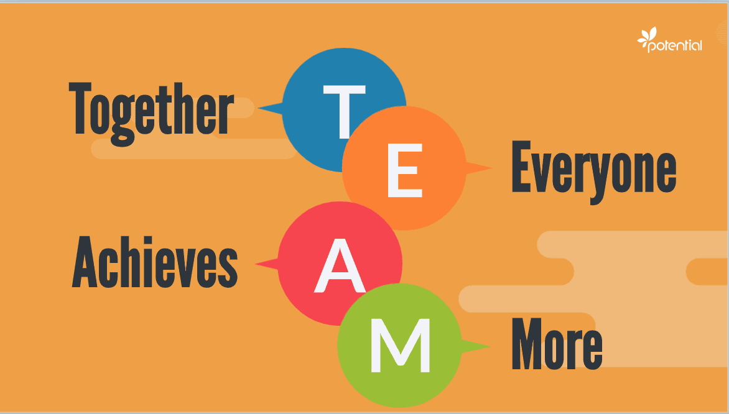

**For my team I divided my team of 5 people into three groups, and each group had its own tasks. The tasks were distributed, and the groups were divided after discussing with all the team members and obtaining their approval.**

**Group A, Event organizers and officials. The task of welcoming visitors:**

|  |  |  |
| --- | --- | --- |
| **M. N** | **Member name** | **Member work** |
| **1** | **Nora Maher** | * **Welcoming people** * **Event check-in** * **Report** * **Customer services** |

48

**Group B, Responsible for the stage and educational lectures**

|  |  |  |
| --- | --- | --- |
| **M. N** | **Member name** | **Member work** |
| **2** | **Najwa Mohammed** | * **Responsible for organizing the stage** * **opening speech for the event** * **team leader** |
| **3** | **Ibrahim Ali** | * **Event Materials** * **Group discussion and workshops manager.** |

**Group C, Responsible behind the scenes for the event such as electrical duties and general supervision of the event**

|  |  |  |
| --- | --- | --- |
| **M. N** | **Member name** | **Member work** |
| **4** | **Alma Mohammed** | * **Electricity Supply** * **Checking with technical service providers** |
| **5** | **Ahmad Hamden** | * **General Responsible for the event** * **deputy leader** |

We divided our team into 3 groups; each group has its duty to achieve specific goals. As I am the team leader of my team my duty is to distribute tasks for members and discuss with them what to do and help them with anything they want. In addition, I have the responsibility for organizing the stage. Also, the opening speech for the event. I will do my best to be a good team leader and help my team to have a wonderful event.

49

In this task, I will examine team dynamics in terms of group member responsibilities and effectiveness in terms of meeting engagement goals. We've decided to provide a training session for folks who are interested in teem building but don't know where to start. As a result, we separated our crew into three sections. Visitors, employee, and employee service should all be greeted by the first group. The second group is in charge of the stage and instructional seminars. The last group is in charge of the event's behind-the-scenes operations, such as electrical tasks and overall event management. I am the team's team leader. So, I will talk about how we can collaborate.

Responsibilities of my group:

As shown in the previous tables, the members were divided into three groups due to the qualifications and personal and practical skills of each member. Dividing large tasks into small tasks helps to ensure the quality of work, the ease of completing the required task, and reaching the desired goal, which is to provide an integrated, wonderful, and enjoyable event. At the beginning of the event, Nora Maher will welcome the visitors and guide them to the hall where the event and events will be held, she also will take care of helping the visitors and solving their problems related to the event. In addition to submitting a report to the team leader on the event after its completion.

As for the event, I'm Najwa Mohammed I will be responsible for organizing the stage's decoration and lighting. In addition, I will have the opening speech for the event in my capacity as team leader and general organizer of the event. While Ibrahim Alimonies the event’s activities and workshops held at the event.

As for the last group, it is responsible for what happens behind the scenes from connecting electricity and communicating with vendors. Alma Mohammed will manage the electrical department while Ahmed Hamden will supervise all tasks for all groups in his capacity as deputy leader.

50

I would like to talk about the definition of CPD, its advantages, and how it advances learning and skill development. I've asked for this because I need to explain how CPD affects organizations and companies because I work for a company with more than 20 employees.[17]

Introduction to CPD:

CPD, or continuing professional development, is the word used to describe the additional learning that professionals engage in. CPD is typically used to supplement and improve employees' talents in the job. However, it entails far more than just learning. [17]

CPD, rather of being passive and reactive, makes learning deliberate and proactive in order to improve personal abilities for use in the job. Furthermore, a range of approaches, such as workshops, conferences, and e-learning or online courses, are used. By participating in CPD, you will ensure that neither your academic nor practical credentials become obsolete. CPD allows you to up skill regardless of where you are in your profession, your age, or your level of schooling. [17]



51

**Benefits of CPD:**

1. **Keeping Up with Evolving Trends:**
   * The ever-changing workplace demands professionals to stay abreast of evolving trends. For instance, the shift to remote work during the Covid-19 pandemic necessitated the adoption of new technologies. Continuous learning ensures that skills remain relevant and prevents them from becoming obsolete. [17]
2. **Improved Workplace Effectiveness:**
   * Enhanced knowledge leads to increased job productivity, creating opportunities for professional advancement. Additionally, sharing newfound information showcases leadership abilities, contributing to a more effective and dynamic work environment. [17]
3. **Maintaining and Expanding Expertise:**
   * Regularly refreshing specific skill sets distinguishes professionals and ensures they deliver superior services. CPD allows individuals to revive dormant skills, providing a foundation for offering exceptional expertise in their respective fields. [17]
4. **Increased Interest in the Field:**
   * CPD introduces professionals to new skill areas and information, combating career fatigue. Exposure to fresh perspectives renews enthusiasm, making individuals more engaged and productive, ultimately leading to increased levels of efficiency. [17]

52

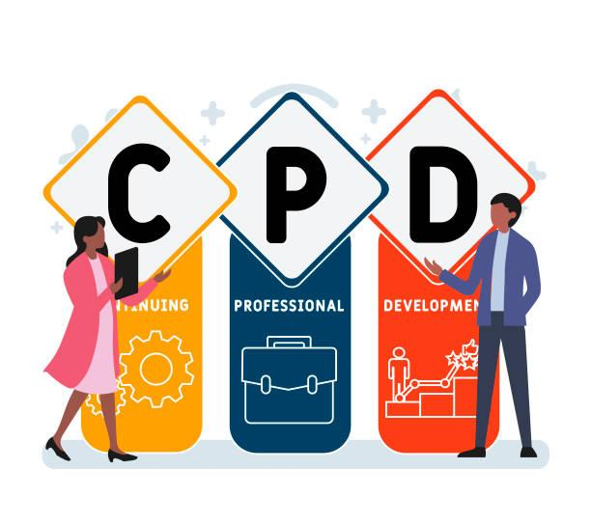

**Tailoring CPD Programs:**

* Crafting an ideal Continuous Professional Development program requires tailoring to individual needs. Each employee possesses a unique skill set and growth goals, presenting a challenge for organizations to accommodate personalized CPD at scale. Despite these challenges, successful CPD programs leverage detailed and employee-specific methods to determine skill requirements. [17]

**The Importance of CPD:**

* CPD extends the learning process by structuring and focusing on specific skills and information, ensuring that professionals continue to evolve. After completing academic credentials, CPD becomes a vital mechanism for ongoing learning in a particular field. [17]

53

**How CPD Helps:**

* CPD benefits individuals by providing a comprehensive overview of career growth, fostering new areas of confidence and skills. It assists in progress monitoring through learning documentation and aids in achieving professional goals. Additionally, CPD facilitates effective communication of professional status to clients and employees, contributing to job advancement and creating new opportunities. [17]

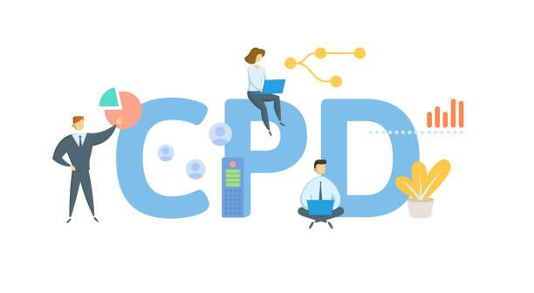

**Measuring the Effectiveness of CPD:**

1. **Time Management:**
   * Effective CPD requires meticulous time management. Organizing tasks efficiently, as demonstrated in the case of organizing a web development event, ensures clarity of thought and timely completion of assignments.[18]

54

1. **Support:**
   * Individuals pursuing CPD require a support system from parents, friends, family, and others. Navigating professional challenges and keeping skills up-to-date is made more achievable with a strong support network. [18]
2. **Reviewing Feedback:**
   * Regular self-review is crucial for effective CPD. evaluating one's capabilities, performance, and strengths allows for improvement. A habit of self-review helps individuals understands their progress and areas for enhancement. [18]
3. **Linking Work and Personal Lives:**
   * There should be a seamless interaction between work and personal lives. Critical thinking skills applied in professional challenges can also be beneficial in solving personal problems. The ability to transfer critical reasoning between domains contributes to effective CPD. [18]

In essence, CPD serves as a cornerstone for continuous growth, ensuring professionals remain adaptive, engaged, and highly skilled in their respective fields. The effectiveness of CPD is measured not only by the acquisition of knowledge but by the practical application of skills in both professional and personal realms. [18]

55

**Introduction to Personal Development Plan (PDP):**

A Personal Development Plan (PDP) stands as a meticulous document encapsulating self-reflection and a roadmap for progress, tailored to foster academic, personal, or career-related goals. Originating typically within the professional or educational realm, PDPs are crafted in collaboration with managers or instructors, offering a platform for individuals to delineate their objectives, recognize strengths and limitations, and pinpoint areas for improvement. Serving as a multifaceted action plan, a PDP empowers individuals to establish clear goals and outline a personalized set of activities to propel them towards achievement.[19]

**Key Components and Purpose of PDPs:**

1. **Self-Reflection:**
   * At the core of a PDP is the practice of self-reflection. Individuals engage in a thoughtful examination of their current standing, assessing achievements, shortcomings, and areas ripe for development. This introspection forms the foundation for setting meaningful and realistic objectives. [19]
2. **Goal Setting:**
   * Objectives within a PDP are meticulously crafted based on identified areas for improvement. These goals can span academic pursuits, personal growth, or career advancements. The specificity of these objectives is paramount, ensuring clarity in the direction of personal development. [19]
3. **Acknowledging Strengths and Limitations:**
   * A PDP prompts individuals to candidly acknowledge their strengths and limitations. Understanding one's capabilities and constraints contributes to a realistic and holistic approach to personal growth. [19]

56

1. **Individualized Activities:**
   * The true efficacy of a PDP lies in its individualization. Each plan is unique to the person crafting it, incorporating activities and strategies tailored to their preferences, learning styles, and professional or academic context. This bespoke approach ensures engagement and commitment to the outlined developmental activities. [19]
2. **Progress Monitoring:**
   * PDPs serve as dynamic documents, not static blueprints. They include mechanisms for ongoing progress monitoring, allowing individuals to track advancements, reassess goals, and adapt strategies as needed. Regular reviews contribute to the agility and relevance of the plan. [19]

**PDPs in Professional and Educational Contexts:**

1. **Professional Development:**
   * In the professional realm, PDPs are instrumental in guiding career growth. Individuals outline aspirations, skill development initiatives, and strategies for overcoming challenges. Managers play a pivotal role in supporting and aligning organizational objectives with individual aspirations.[20]
2. **Academic Pursuits:**
   * Within educational settings, PDPs function as roadmaps for academic achievement. Students collaborate with instructors to set learning objectives, identify study methodologies, and articulate strategies for overcoming academic hurdles. PDPs become tools for fostering a proactive and empowered approach to learning. [20]

57

**Benefits of Implementing PDPs:**

1. **Clarity of Purpose:**
   * PDPs provide a clear roadmap for personal and professional development, offering a sense of purpose and direction. This clarity contributes to increased motivation and engagement in pursuing goals.[20]
2. **Empowerment and Ownership:**
   * Crafting a PDP instills a sense of empowerment and ownership in individuals. The process of setting personalized goals and determining the path to achieve them fosters a proactive and self-directed mindset.[20]
3. **Enhanced Self-Awareness:**
   * Engaging in self-reflection within a PDP cultivates enhanced self-awareness. Individuals gain a deeper understanding of their strengths, limitations, and areas for improvement, laying the groundwork for targeted growth. [20]
4. **Structured Learning:**
   * PDPs bring structure to the learning and development process. The inclusion of specific activities and milestones provides a framework for continuous improvement, making the journey towards goals more organized and effective. [20]

58

1. **Adaptability and Resilience:**
   * The iterative nature of PDPs promotes adaptability and resilience. Regular reviews and adjustments allow individuals to respond to changing circumstances, overcome challenges, and stay aligned with their overarching objectives. [20]

Personal Development Plans are powerful tools for fostering intentional growth and progress. Grounded in self-reflection, goal-setting, and individualization, PDPs empower individuals to take charge of their development journeys. Whether in a professional or educational context, the structured and dynamic nature of PDPs contributes to enhanced self-awareness, clarity of purpose, and a resilient approach to personal and professional challenges. As a dynamic framework, the impact of PDPs extends beyond mere planning; they become catalysts for continuous improvement and lifelong learning. [20]

|  |  |  |  |  |  |
| --- | --- | --- | --- | --- | --- |
| **CPD for our team** | | | | | |
| **Team Member** | **Strengths** | **Responsibility** | **Weakness** | **Strategy to improve** | **Measure** |
| **Najwa Mohammed** | **Conflict resolution**  **Team leader**  **Time management** | **To present a wonderful event and facing all challenges.** | **Communication skills** | **Talk more with people and interact with them.** | **10/1/2024**  **To**  **4/4/2024** |
| **Nora Maher** | **Organizational and planning skills** | **Greeting the learners and help them to reach the halls** | **Bad in managing her time** | **It is necessary to create a timetable and schedule daily tasks and work properly.** | **10/1/2024**  **To**  **4/4/2024** |
| **Ibrahim Ali** | **Persuasion and influencing skills** | **Group discussion and workshops manager.** | **Bad communication skills** | **Talk more with people and interact with them.** | **10/1/2024**  **To**  **4/4/2024** |
| **Ahmad Hamden** | **Rapport-building and listening**  **Decision-making** | **General Responsible for the event**  **deputy leader** | **Difficulty in communication. Introvert** | **Try to actively engage in communicating with members more often** | **10/1/2024**  **To**  **4/4/2024** |
| **Alma Mohammed** | **Problem-solving** | **Electricity Supply**  **And checking with technical service providers** | **Time management is poor.** | **Needs to prepare a work schedule and adjust accordingly.** | **10/1/2024**  **To**  **4/4/2024** |

Table 2. Evidence of CPD

60

**Introduction to Motivation Theory:**

Motivation theory delves into the intricate mechanisms that propel individuals towards specific goals. Far from perceiving motivation as an elusive human quality, these theories provide a research-backed framework, unraveling the intricacies of what truly drives individuals forward. It's not a one-size-fits-all strategy; instead, motivation theory stands as an umbrella term encompassing a plethora of ideas, each offering its unique perspective on the ideal "recipe" for workplace motivation.

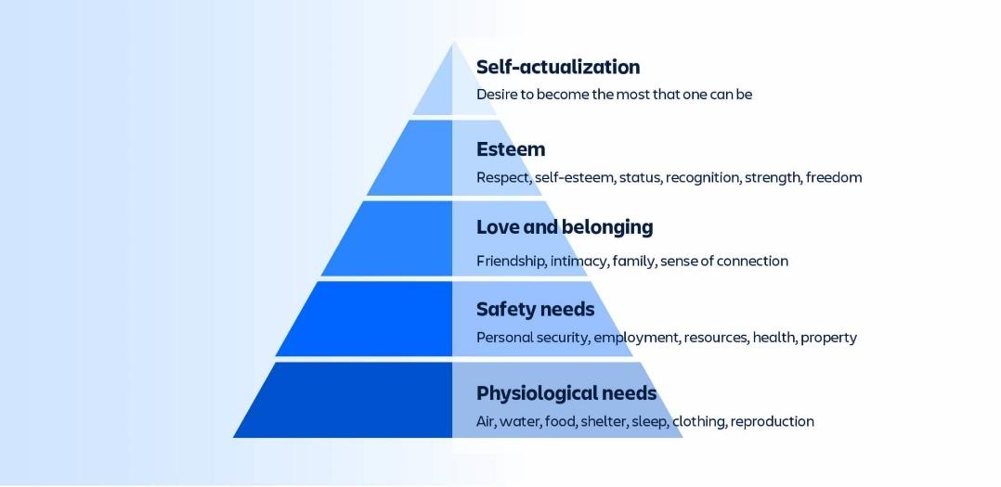**Examples of Popular Motivation Theories to Inspire Teams:**

1. **Maslow’s Hierarchy of Needs:**
   * Originating from psychologist Abraham Maslow's seminal work in 1943, "A Theory of Human Motivation," Maslow's hierarchy of needs is a foundational theory. The theory outlines five layers of human needs structured as a pyramid:
     + Physiological needs: Food, drink, shelter, air, sleep, clothing, and reproduction.
     + Safety needs: Employment, resources, health, property, and personal safety.
     + Belonging and love: Family, friendship, intimacy, and connection.
     + Esteem: Status, recognition, self-esteem, and respect.
     + Self-actualization: Realizing one's full potential.
   * This theory posits that individuals prioritize basic needs at the pyramid's base, progressing to higher-order needs as the lower ones are satisfied. Although originally focused on general human needs, Maslow's hierarchy has been adapted for workplace contexts over the years.[21]

61

1. **Herzberg’s Motivation-Hygiene Hypothesis:**
   * Formulated by Frederick Herzberg in 1959, the motivation-hygiene hypothesis centers on two factors that determine employee satisfaction or dissatisfaction:[22]
     + Hygiene factors: Working environment, remuneration, supervision, and business policies. Their presence ensures stability in employee satisfaction, and their absence causes dissatisfaction.
     + Motivators: Perks, recognition, and growth opportunities. Their presence amplifies motivation, productivity, and commitment.
   * Herzberg's hypothesis simplifies employee satisfaction dynamics: Hygiene factors prevent dissatisfaction, while motivators elevate satisfaction and motivation when basic hygiene is intact.

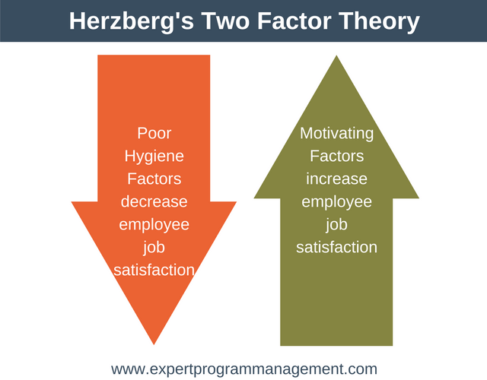

62

1. **Reinforcement Theory:**
   * Rooted in operant conditioning and often associated with B.F. Skinner, the reinforcement theory is underpinned by Edward Thorndike's law of effect. This theory operates on the premise that consequences influence behavior, either through positive reinforcement (pleasant consequence) or negative reinforcement (cessation or removal of a negative outcome).[23]
   * In essence, the theory focuses on the cause-and-consequence dynamics, emphasizing that behaviors leading to favorable outcomes are likely to be repeated.

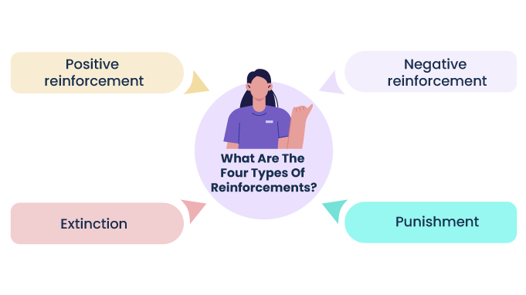

63

**This approach focuses on cause and consequence rather than our internal drives. If we accomplish something and enjoy the outcome, we will do it again.**

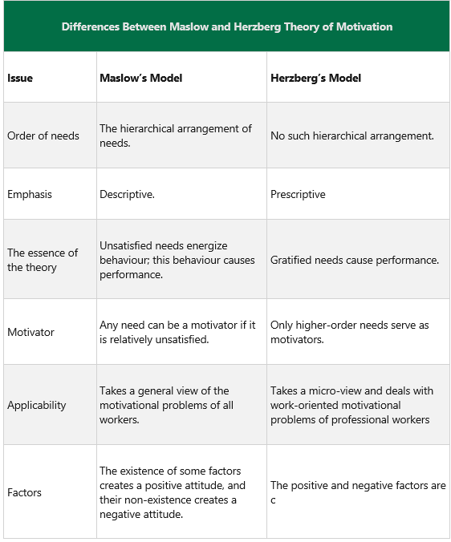

64

**Implications of Motivation Theories in the Workplace:**

1. **Tailored Approach:**
   * Understanding diverse motivation theories allows organizations to adopt a tailored approach. Recognizing that individuals respond differently to various motivational strategies enables leaders to craft nuanced approaches that resonate with diverse teams.[24]
2. **Employee Engagement:**
   * Implementing elements from these theories enhances employee engagement. Addressing both hygiene factors and motivators ensures a holistic strategy that fosters satisfaction, commitment, and sustained motivation among team members. [24]
3. **Leadership Strategies:**
   * Motivation theories guide leadership strategies. Leaders armed with insights from these theories can adeptly navigate challenges, create conducive work environments, and provide the necessary stimuli to drive team members towards success. [24]

**Conclusion:**

In conclusion, motivation theories provide a comprehensive understanding of the intricate dynamics that drive individuals within the workplace. From Maslow's foundational hierarchy to Herzberg's dual-factor hypothesis and the reinforcement theory's behavior-centric approach, these theories offer valuable insights for organizational leaders. Employing a nuanced blend of these theories enables organizations to create motivational frameworks that inspire, engage, and propel teams towards collective success. [24]

65

References

[1] E. Youth Justice, “Communicating effectively.” Accessed: Jan. 15, 2024. [Online]. Available: https://www.business.qld.gov.au/running-business/marketing-sales/sales/communicating-effectively

[2] “4 Types of Communication and How To Improve Them | Indeed.com.” Accessed: Jan. 15, 2024. [Online]. Available: https://www.indeed.com/career-advice/career-development/types-of-communication

[3] “What is Interpersonal Communication? Skills, Types, and Examples | Simplilearn,” Simplilearn.com. Accessed: Jan. 15, 2024. [Online]. Available: https://www.simplilearn.com/what-is-interpersonal-communication-article

[4] “Formal and Informal Language | Touro University.” Accessed: Jan. 15, 2024. [Online]. Available: https://www.touro.edu/departments/writing-center/tutorials/formal-vs-informal-language/

[5] “Interpersonal Skills,” Corporate Finance Institute. Accessed: Dec. 20, 2023. [Online]. Available: https://corporatefinanceinstitute.com/resources/management/interpersonal-skills/

[6] “What Are Soft Skills? Definition, Importance, and Examples,” Investopedia. Accessed: Jan. 15, 2024. [Online]. Available: https://www.investopedia.com/terms/s/soft-skills.asp

[7] “Elevate Your Efficiency with Time Management Tips.” Accessed: Jan. 15, 2024. [Online]. Available: https://www.linkedin.com/pulse/elevate-your-efficiency-time-management-tips-lana-sheppard-ahz2c

[8] M. C. Team, “SMART Goals - How to Make Your Goals Achievable.” Accessed: Jan. 15, 2024. [Online]. Available: https://www.mindtools.com/a4wo118/smart-goals

[9] S. Wyatt, “Creative Problem Solving for Event Design in 3 Easy Steps!,” CanadianSpecialEvents.com. Accessed: Jan. 15, 2024. [Online]. Available: https://canadianspecialevents.com/creative-problem-solving-for-event-design-in-3-easy-steps/

[10] GoLeanSixSigma.com, “DMAIC - The 5 Phases of Lean Six Sigma,” GoLeanSixSigma.com (GLSS). Accessed: Jan. 15, 2024. [Online]. Available: https://goleansixsigma.com/dmaic-five-basic-phases-of-lean-six-sigma/

[11] O. Muscad, “The 5W1H Method: A Comprehensive Guide,” DATAMYTE. Accessed: Jan. 15, 2024. [Online]. Available: https://datamyte.com/blog/5w1h-method-comprehensive-guide/

[12] “Trial and Error: Fail your way to Success.” Accessed: Jan. 15, 2024. [Online]. Available: https://www.linkedin.com/pulse/trial-error-method-success-andre-lord

[13] “The 80-20 Rule (aka Pareto Principle): What It Is, How It Works,” Investopedia. Accessed: Jan. 15, 2024. [Online]. Available: https://www.investopedia.com/terms/1/80-20-rule.asp

[14] “Tuckman: Forming, Storming, Norming and Performing Model – BusinessBalls.com.” Accessed: Jan. 15, 2024. [Online]. Available: https://www.businessballs.com/team-management/tuckman-forming-storming-norming-performing-model/

[15] “What Is Team Dynamics? Importance, Key Elements, and Factors • ActiveCollab,” ActiveCollab. Accessed: Jan. 15, 2024. [Online]. Available: https://activecollab.com/blog/collaboration/team-dynamics

[16] “10 must-haves for successful team collaboration | Slack.” Accessed: Jan. 15, 2024. [Online]. Available: https://slack.com/blog/collaboration/10-tips-for-successful-team-collaboration

[17] “What is CPD Continuing Professional Development Explained | The CPD Certification Service.” Accessed: Jan. 15, 2024. [Online]. Available: https://cpduk.co.uk/explained

[18] “How can you measure the impact of CPD?” Accessed: Jan. 15, 2024. [Online]. Available: https://blog.irisconnect.com/uk/community/blog/how-can-you-measure-the-impact-of-cpd/

[19] “Free Personal Development Plan (PDP) | Example Template PDF.” Accessed: Jan. 15, 2024. [Online]. Available: https://www.highspeedtraining.co.uk/hub/personal-development-plan-template/

[20] “Full article: Developing teacher in-service education through a professional development plan: modelling the process.” Accessed: Jan. 15, 2024. [Online]. Available: https://www.tandfonline.com/doi/full/10.1080/02619768.2020.1827393

[21] “Reading: Introduction to Motivational Theory | Introduction to Business |.” Accessed: Jan. 15, 2024. [Online]. Available: https://www.coursesidekick.com/business/study-guides/introbusinesswmopen/reading-motivating-employees

[22] F. Herzberg, “Motivation-hygiene theory,” in *Organizational Behavior 1*, Routledge, 2015, pp. 61–74. Accessed: Jan. 15, 2024. [Online]. Available: https://www.taylorfrancis.com/chapters/edit/10.4324/9781315702018-7/motivation-hygiene-theory-frederick-herzberg

[23] “What is the reinforcement theory of motivation?” Accessed: Jan. 15, 2024. [Online]. Available: https://www.techtarget.com/whatis/definition/reinforcement-theory

[24] “5 Motivation Theories To Use in the Workplace (With Tips) | Indeed.com.” Accessed: Jan. 15, 2024. [Online]. Available: https://www.indeed.com/career-advice/career-development/motivation-theories

66